**Question – 1 Write a function to calculate length of the string**

**Ans.**

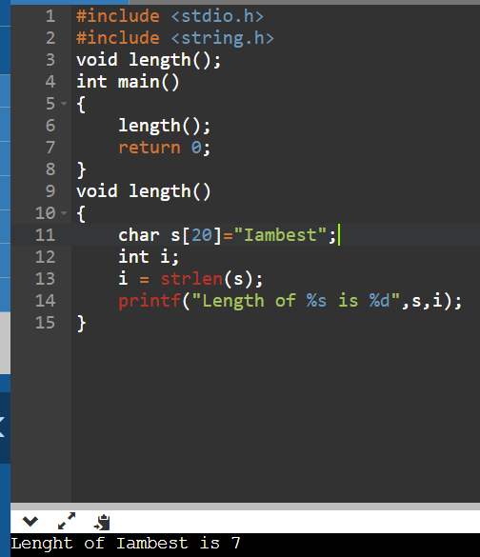

**Question – 2 Write a function to reverse a string..**

**Ans.**

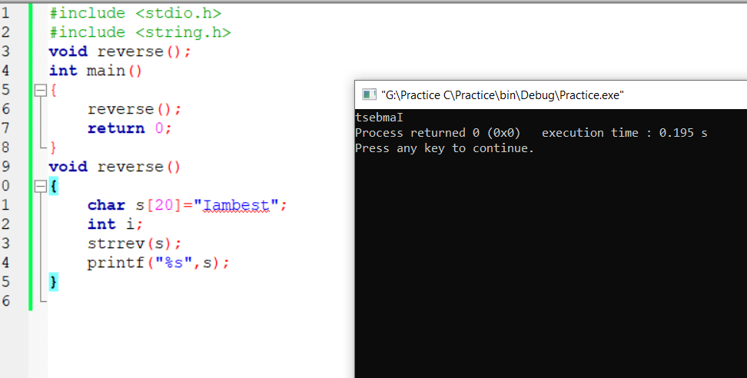

**Question – 3 Write a function to compare two strings.**

**Ans.**

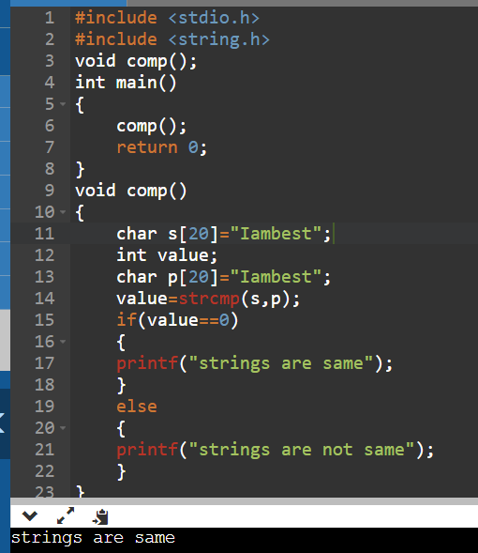

**Question – 4 Write a function to transform string into uppercase.**

**Ans.**

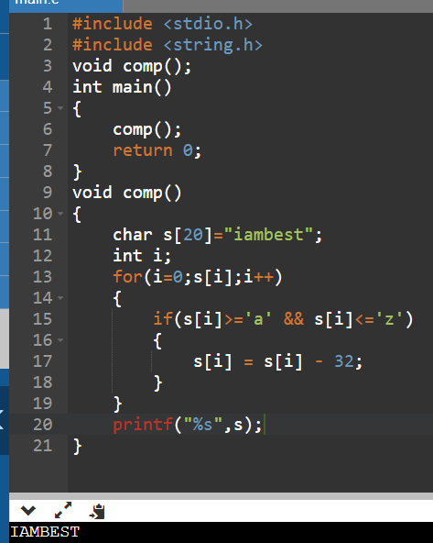

**Question – 5 Write a function to transform a string into lowercase**

**Ans.**

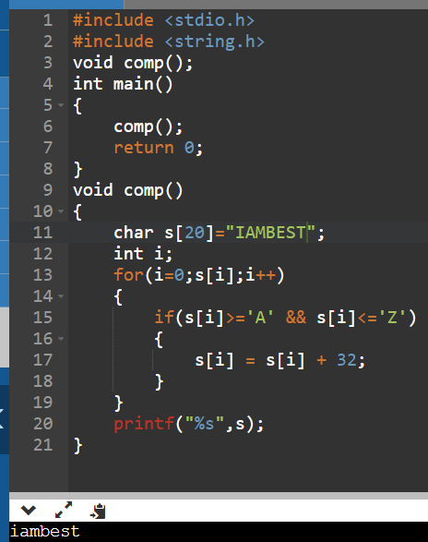

**Question – 6 Write a function to check whether a given string is an alphanumeric string or not.**

**(Alphanumeric string must contain at least one alphabet and one digit).**

**Ans.**

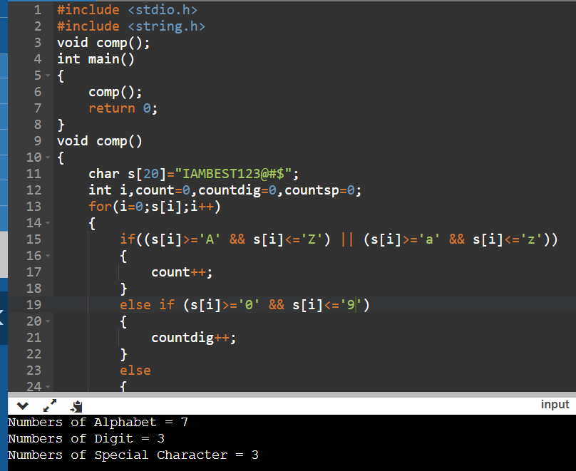

**Question – 7 Write a function to check whether a given string is palindrome or not.**

**Ans.**

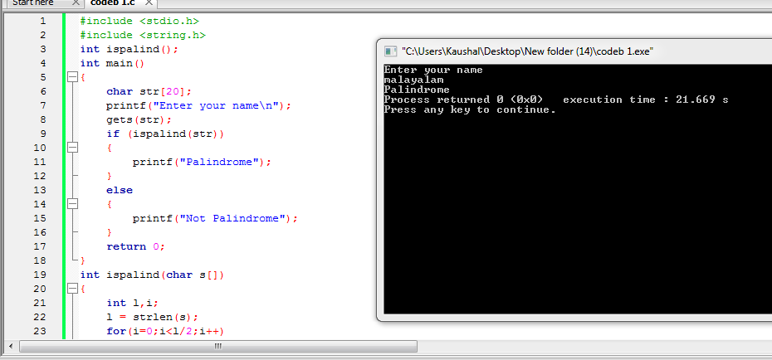

**Question – 8 Write a function to count words in a given string**

**Ans.**

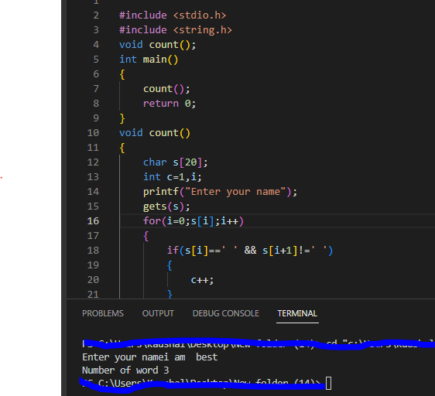

**Question – 9 Write a function to reverse a string word wise. (For example if the given string is**

**“Mysirg Education Services” then the resulting string should be “Services Education**

**Mysirg” )**

**Ans.**

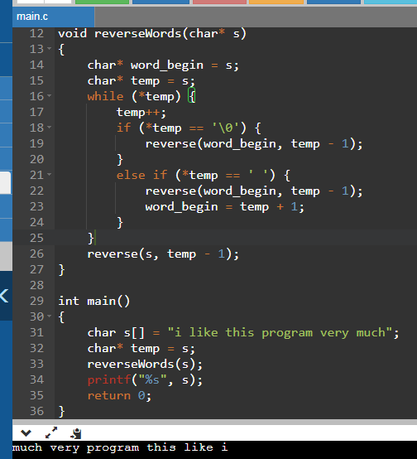

**Question – 10 Write a function to find the repeated character in a given string.**

**Ans.**

